**Eva Lipska**

**Report**

**UNITED NATION GENERAL ASSEMBLY VOTES**

**1946 - 2017**

**The goal of the project**

The analysis of the United Nations General Assembly votes from 1946 to 2017, including predictive modeling analysis.

**Data**

**Source of the data**

United Nations General Assembly Voting (DataVersion 18.0)

Voeten, Erik; Strezhnev, Anton; Bailey, Michael, 2009, "United Nations General Assembly Voting Data", <https://hdl.handle.net/1902.1/12379>, Harvard Dataverse, V18, UNF:6:xkt0YWtoBCThQeTJWAuLfg==

**Data structure**

The dataset consists of 1099156 observations representing voting records of every membership country from 1946 to 2017 as well as detailed information about the voting process covered by 26 variables – resolution, session, date, membership status, voting results, the topic of a resolution (Palestinian conflict, nuclear weapons and nuclear material, arms control and disarmament, colonialism, human rights, economic development) etc.

**Research questions**

Are there any patterns of the UN General Assembly voting process, based on years, countries, topics or regions?

Do selected countries tend to agree or disagree with the international consensus?

Do countries have consistent agendas toward UN policy, relating to particular periods of time or topics?

**Predictive analysis**

**Goal: Prediction if a country will agree, disagree or** decline to vote either for or against a resolution **which is a result of the international consensus.**

**Type of the problem: multiclass classification**

voting “yes" for resolutions - country agrees with the international consensus

voting "no" for resolutions - country is against the international consensus

*voting “abstain”* - country formally decline to vote either for or against a resolution.

**Limitations of the analysis**

As the dataset includes massive amount of information covering 71 years of the international relations history, the analysis presents general overview of the UN General Assembly voting process. Further research problems may be defined on its basis.

## Exploratory Data Analysis

**Votes vs Years**

Dominant amount - 80 % - of votes in the analyzed period are 'yes' votes; 'no' votes – are only 7 % and abstain votes - 13 %.

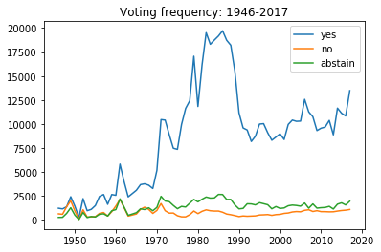

There are strong patterns based on time periods observed:

* high increase in “yes” votes in the ‘70s;
* high frequency of ‘yes’ votes in the ’80s;
* the second half of the ‘70s through the '80s is the most active period in the UN General Assembly voting history, revealing optimism toward international resolutions; recent three decades indicate a drop in interest in the common agenda;
* proportional relationship graph shows high drop in “no” votes from the ‘50s through the ‘70s;
* the period of time with the highest frequency of disagreements (‘no’ votes) and the lowest frequency of agreements (‘yes’ votes) - was in the '50s and the '60s, when series of international crises occurred;
* frequent drops in the frequency of ‘yes’ votes indicates international crises;
* frequency of “abstain” votes keeps a constant level.

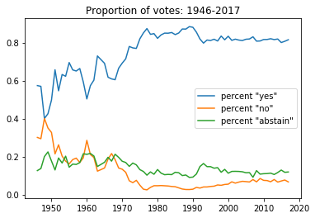

The change of the pattern do not necessarily indicates the higher level of consensus among countries.

Hypothesizes for consideration:

* resolutions aren't that controversial anymore, the most controversial issues are avoided because there is no will for an agreement on the international forum: for this reason UN is accused of being inefficient;
* high level of agreements may be caused by politically more stable periods: F. Fukuyama and his naïve concept of "The End of History" (1991): from now on all the countries accept the western liberal democracy;
* some subjects (ex. Palestine) may not attract public attention anymore.

### **Votes vs Countries and Years**

**Five countries – permanent members of the UN Security Council: China, France, Russian Federation, the United Kingdom, and the United States, has been chosen for the further analyses. The graphs below present the frequency of votes as well as the percentage of their ‘yes’ votes in the UN history.**

|  |  |
| --- | --- |
| **C:\Users\ezlip\AppData\Local\Microsoft\Windows\INetCache\Content.MSO\9066F780.tmp** | **C:\Users\ezlip\AppData\Local\Microsoft\Windows\INetCache\Content.MSO\C266B52B.tmp** |
| **C:\Users\ezlip\AppData\Local\Microsoft\Windows\INetCache\Content.MSO\664E18BA.tmp** | **C:\Users\ezlip\AppData\Local\Microsoft\Windows\INetCache\Content.MSO\5DEED5DF.tmp** |
| **C:\Users\ezlip\AppData\Local\Microsoft\Windows\INetCache\Content.MSO\3C6AD037.tmp** | **C:\Users\ezlip\AppData\Local\Microsoft\Windows\INetCache\Content.MSO\4E6FE2BE.tmp** |
| **C:\Users\ezlip\AppData\Local\Microsoft\Windows\INetCache\Content.MSO\E2C76AF9.tmp** | **C:\Users\ezlip\AppData\Local\Microsoft\Windows\INetCache\Content.MSO\2EE8A488.tmp** |
| **C:\Users\ezlip\AppData\Local\Microsoft\Windows\INetCache\Content.MSO\C6607EE.tmp** | **C:\Users\ezlip\AppData\Local\Microsoft\Windows\INetCache\Content.MSO\3FE1AC3D.tmp** |

**Votes vs Topics, Countries and Years**

**Votes relating to six subjects of the resolutions has been analized:**

* Palestine conflict
* nuclear weapons and nuclear material
* arms control and disarmament
* human rights
* colonialism
* economic development

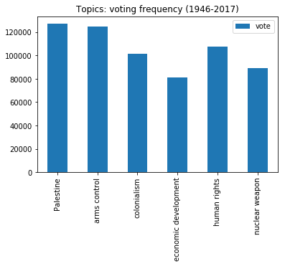

The charts below present the comparitnion of votes of the six countries**: China, France, Russian Federation, the United Kingdom, and the United States** relating to different topics.

**China**

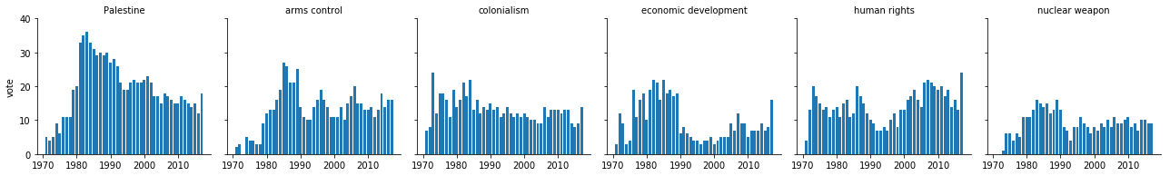

**France**

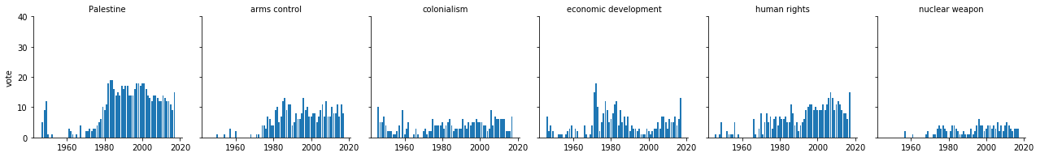

**Russian Federation**

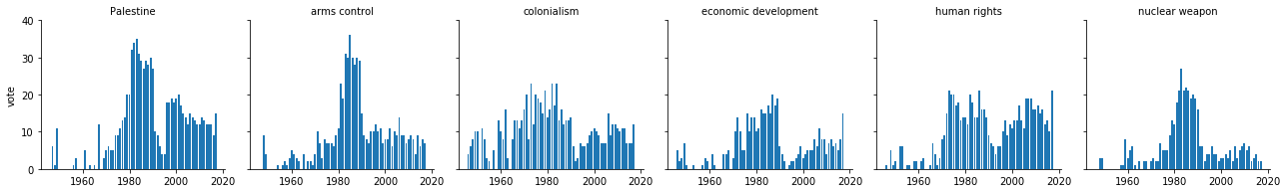

**United Kingdom of Great Britain and Northern Ireland**

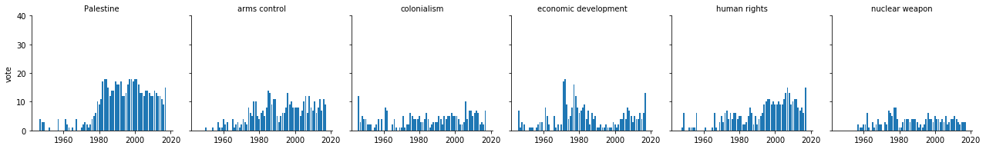

**United States of America**

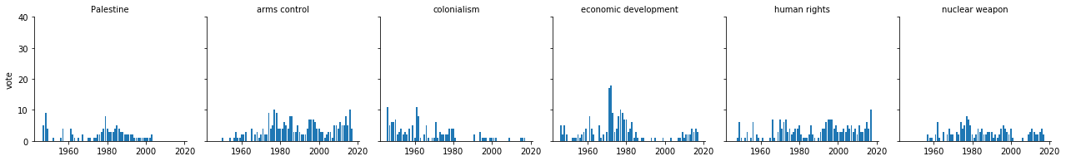

**Modeling**

Predictive modeling with the use of 8 classifiers and 10 fold cross validation method.

Selection of the algorithms: K-Nearest Neighburs, Support Vector Machine, Random Forest, Logistic Regression, Decision Tree Classifier, Extra Tree Classifier, Nearest Centroid and Bernoulli NB.

Decision Tree Classifier has been chosen as a final model. In this case accuracy is not a reliable metric because the class distribution is unbalanced (it gives high scores to models which just predict the most frequent class). However other metrics of the Decision Tree Classifier show its good performance (around 89 percent)

Tuning with the use of ResearchGrid method didn’t improve the metrics.

**Decision Tree Classifier**

**Metrics**

accuracy: 0.89

recall_micro: 0.89

recall_macro: 0.79

precision_micro: 0.89

precission_makro: 0.78

completeness_score: 0.44

**Conclusions**

The analysis presents the overall picture of the United Nations General Assembly decision process history. It reveals some patterns that should be a subject to a further analysis in a historical and political context, which enables to answer the question for example about political agendas of particular countries. However, at this point, it's noticeable that the USA is not the enthusiasts of the common international approach, comparing to China or Russian Federation. The analysis of the countries in the regional context requires prior data preparation.